|  |  |  |
| --- | --- | --- |
| Group Project Reserve Plant Species | October 27  2014 | |
| Project Plan | | Group 10 |

Contents

1 Introduction 1

1.1 Scope 1

1.2 Objectives 1

2 Overview 2

2.1 Operating Systems and High Level Architecture 2

2.2 Android App. Architecture 2

2.3 Web Server and Maintenance 3

3 Use Case diagram 4

3.1 Use Case Descriptions 5

4 User Interface 7

4.1 RPSR view Web Interface 7

4.2 RPSR rec Android Application 9

5 Gantt Chart 12

6 Risk Analysis 14

Risk Frequency Key 16

Risk Severity Key 16

## 1 Introduction

In this document we are to discuss problems that we may encounter during the project and how we are going to negate them. This document will also include a Gantt chart that will show what parts of the project will be worked on and when.

### Scope

The scope of this document is to show the overview of the project highlighting main points. Demonstrate preliminary designs that have been drawn up a Gantt chart to show what parts of the project are being worked on and when. Finally a risk assessment to analyse any problems we may encounter and how we are going to negate them.

### Objectives

Our main objectives with this document are as follows:

1.1.1 Design Drawings  
1.1.2 Use case Diagrams   
1.1.3 Gantt chart  
1.1.3 Risk Assessments

## 2 Overview

### **2.1 Operating Systems and High Level Architecture**

The main operating system and languages for the project.

#### 2.1.1 PHP

PHP is the coding language used on the web server side end to create the plant recording website.

#### 2.1.2 Java

Java is the main coding language being used for the android application for the app-side development.

#### 2.1.3 SQL

The database programming language used to create and hold all the relevant data added by the android application and the website data through the use of a relational database management system.

#### 2.1.4 Android

The mobile operating system based off of linux which will be used as the main mobile operating system for the application.

### 2.2 Android App. Architecture

The android app. will be started by touching the app. icon and will then present the user with the options specified in the specification.

#### 2.2.1 Start-up Session on android device

The user will be given a prompt to register their details with the server. Once completed the user will be able to records their observations. There will be a chance to record at another site again without the need to re-register the information.

#### 2.2.2 Registration about web visit

Every time the user starts the app. the option to register will be available to them; once registered the user can repeatedly record at other sites.

#### 2.2.3 Species recording feature

The species entered will be added to a drop down list of an already existing list on the database side.

#### 2.2.4 Species details feature

The species details feature requires the user to add the abundance of the species as well as a text block to comment on the species. There will be an option to take a photo of the plant species from the android app using the device camera. There will be an option to show the location of the species via the android application through the devices GPS function.

#### 2.2.5 Editing of Plant Record feature

The ability of the user to delete any records from one species as well as the ability to delete whole recordings of user made records; the ability to change any existing information in existing species records.

#### 2.2.6 Record Capture to be sent to Server

The recordings will be sent to the database through a formatted Multipurpose Internet Mail Extensions message and sent to the server via a HTTP post to the predefined URL. Sent data will include the information about the visit and the information about each species being recorded.

### 2.3 Web Server and Maintenance

The maintenance of the website, app and database.

#### 2.3.1 Reserve Data Maintenance

The reserve on the database should include the users name on one, the OS location on a grid on and the textual description.

## OLE-object

## 3 Use Case diagram

### 3.1 Use Case Descriptions

|  |  |  |
| --- | --- | --- |
| ANDROID APP USER / NATURALIST | | |
| New visit | FR1 | The user will be able to create a new visit. |
| Identify site | FR2 | When creating a new recording, the user will have to identify the site at which the recording will be made. |
| Enter contact details | FR2 | When creating a new recording for the first time, the user will be prompted to enter contact details. |
| New species | FR3 | User will be able to select the species from a provided list. |
| Provide name for species | FR3 | In case the species is not in the provided list, the user will be able to provide a name. |
| Abundance | FR4 | The user will be able to select a value of the “DAFOR” scale. |
| Free text comment | FR4 | The user will be able to add an optional free text comment. |
| Photo of specimen/scene | FR4 | The user will be able to select two photos from their photo gallery or use the camera on the android phone to make photos of the specimen and the general scene. |
| Edit species | FR5 | The user will be able to edit details of any recorded species. |
| Delete species | FR5 | The user will be able to delete any recorded species. |
| Delete visit | FR5 | The user will be able to delete a whole recorded visit. |
| Send recording | FR6 | The user will be able to send the recording of the whole visit including all its species when possible, this includes the information from (FR2, FR3 & FR4). |

|  |  |  |
| --- | --- | --- |
| ANDROID OS / USERS PHONE | | |
| Obtain date and time | FR2 | The users phone will provide the date and time needed to complete the information for the visit record. |
| Obtain GPS data | FR4 | The users phone must be able to obtain the GPS coordinates, needed for the typical location of a species. |
| Create new picture | FR4 | The phone will make it possible for the user to shoot a picture using the integrated camera. |
| Obtain picture | FR4 | The phone will make it possible for the user to select an existing picture from its gallery. |
| Send information | FR6 | The phone will be able to send the information of the recordings when network communication is available. |

|  |  |  |
| --- | --- | --- |
| SERVER / DATABASE | | |
| Receive recording | FR7 | The server should be able to receive recordings sent from android devices. |
| Store recording | FR7 | The server should be able to store user submitted recordings with all of the relevant data. |
| Store reserve | FR8 | The server should be able to store information about nature reserves in a database. |

|  |  |  |
| --- | --- | --- |
| ADMINISTRATOR | | |
| Create Reserve | FR8 | The administrator should be able to add new nature reserves to the database. |
| Update reserve | FR8 | The administrator should be able to update information about nature reserves in the database. |
| Delete reserve | FR8 | The administrator should be able to delete nature reserves from the database. |

|  |  |  |
| --- | --- | --- |
| WEBSITE VISITOR | | |
| View reserve | FR8 | The user should be able to view all of the nature reserves currently stored in the database. |
| View recording list | FR9 | The user should be able to view all recordings currently stored in the database. |
| Sort by reserve | FR9 | The user should be able to find all of the recordings taken at a specified nature reserve. |
| Sort by date | FR9 | The user should be able to sort the recordings in date order. |

## 4 User Interface

### 4.1 RPSR view Web Interface

The client wanted a website for the Reserve Plant Species Recording called RPSR view (not to be confused with RPSR rec – the Android application). With two foundational functions:

1. Addition and maintenance of records of reserves;
2. Viewing of species records for reserves.

We have come up with the solution being a very basic PHP based web site. The home page will be a list of all plants on the database, with an image of the plant, name, occurrence, status on the DAFOR scale, and a short summary.

The second page will be allowed to manage existing records, add new records and delete records. Its database will use MySQL. To access this page the user must login using an ID and a password.

There will be a third web page, which will only be shown if the user tries to access the ‘manage’ page without logging in.

C:\Users\Christopher Malton\AppData\Local\Microsoft\Windows\INetCache\Content.Word\web design 1.tiff

The page above is the first page users will see when they visit the web site. At the top right, there is an option to authenticate and log in to the web page to allow managing of the records. However, for regular users, there is the option to browse through the current records, without having to use a login.

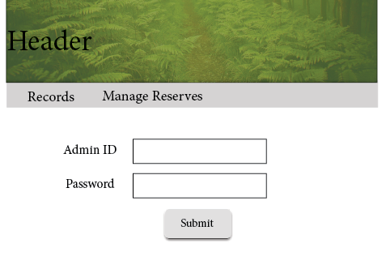

The second page will consist of forms and text boxes to add text. The first one form will allow addition of an image file. Followed by a text box to enter the name of the plant (this will also be the primary key on the database), which will be used to identify the records. The occurrence textbox will be able to contain multiple values. The Status will have a form, to let users choose from a number of options. It will be using the DAFOR scale to identify the abundance or rarity of the plant. It will allow the user to choose from the following:

D- Dominant  
A- Abundant  
F- Frequent  
O- Occasional  
R- Rare

Finally, the summary will let the user enter a short description of the plant.

The final page will only occur if someone tries to click the ‘Manage Records’ button on the navigation bar, without being logged in. It will inform the user that they have to be logged in to access the management page and prompt them to enter a user ID and Password if they are authorized. Alternatively the navigation bar will allow them to go back to the ‘List of Records’ page to view the records without logging in.

We decided that for the purpose that the client wanted, this web site is more than sufficient. The Android application will have further options and will be the main point of interaction. The web site is mainly going to be used to manage the records.

### 4.2 RPSR rec Android Application

The user interface (UI) is designed with the aim to make it easy and quick for the user to record their findings. We are also planning on implementing the swipe action to move from page to page.

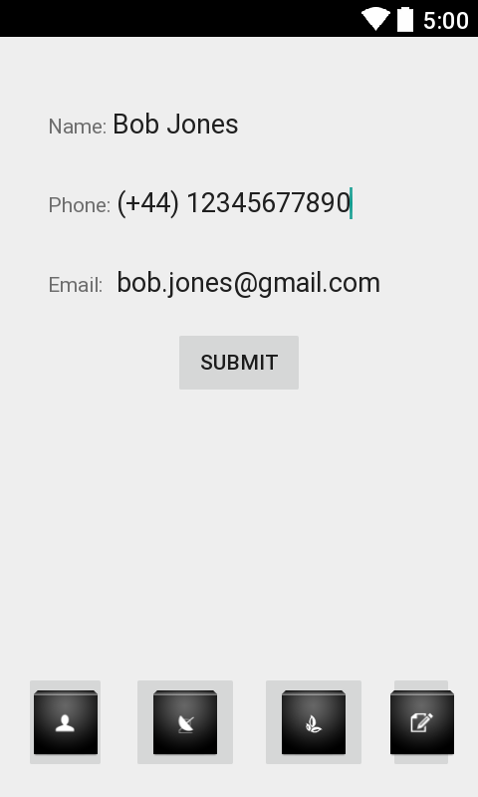

#### 4.2.1 Start-up

This is the first page the user will ever see. This page will automatically appear when the application is run for the first time. After the first run the user will not be prompted to insert their details. The aim of this page is to store the user details so that it can be sent with every record they upload. The user still has the ability to change this information at any time by simple tapping the user details icon at the bottom of the application. Alternatively they can press the appropriate edit button available in the summery page. Pressing the submit button will save the details locally on the device. This information is not sent to any database.

#### 4.2.2 Location

The location page is the page that comes after the user details page. This page will technically be the home page for the application. This page will be the first page to appear to the user after the first load of the application. We have decided to make it the first page so that the user can quickly fill in data rather than have to go through a bunch of options before they can insert data. This page will contain details about the reserves location.

#### 4.2.3 Plant info

The plant information page comes after the location page, it contains details about the plant.

#### 

#### 4.2.4 Summary

This is the last page for this application. It allows the user to view all the data that will be inserted in the record. As well as allowing them to see the data it also has edit buttons next to each section so that the user can be redirected to the page immediately to edit the data that needs changing. The submit button will send the record to the database.

## 5 Gantt Chart

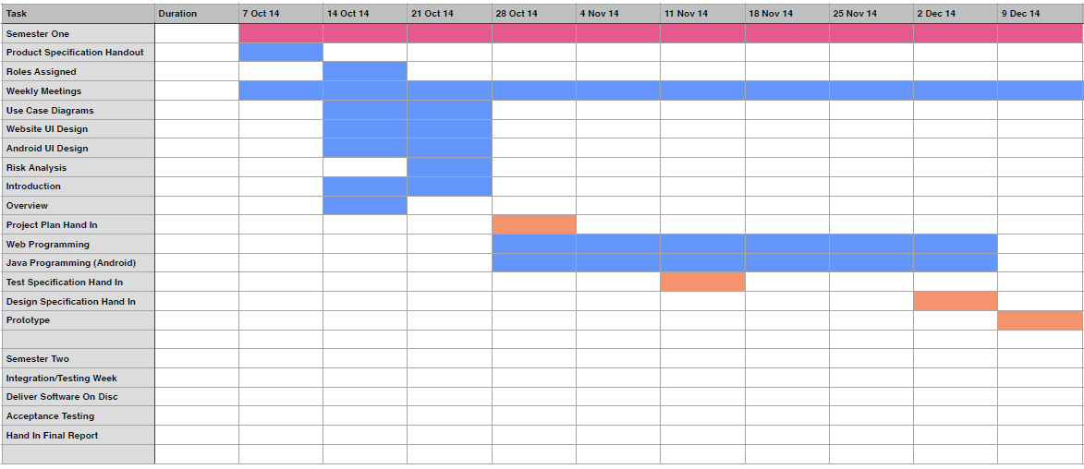

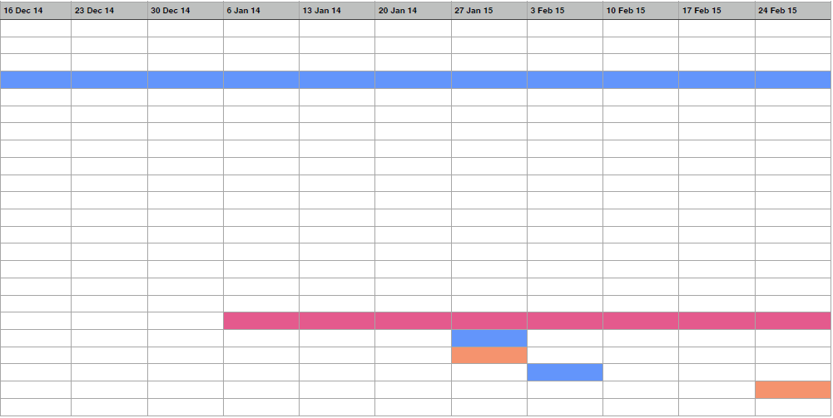

## 6 Risk Analysis

|  |  |  |  |  |
| --- | --- | --- | --- | --- |
| Event | Effects | Risk Frequency Level | Risk Severity Level | Mitigation |
| Continuous Risks |  |  |  |  |
| Illness or other unexpected circumstances | Task assigned to team member may not be completed. | Medium | Medium | Team must be notified as soon as possible, so project does not fall behind on deadlines or finishing work. |
| Absence of team member | Task assigned to team member may not be completed. Also may miss important info/actions. | Medium | Medium | Make sure all meeting are planned in advance.  All absences need to be explained and the absent member must catch up on what was missed. |
| Management Risks |  |  |  |  |
| Team members lacking in skill needed for a particular task | Task may take longer or not completed. | Low | Medium | Set small tests, to see who has which skills. |
| Unrealistic estimates | Run out of time.  Deadlines not met. | Low | Medium | Better organisation of team members and tasks. Should not be over ambitious. |
| Project progress has insufficient monitoring | Team members not knowing what to do.  Overlapping tasks. | Low | High | Regular meetings.  Regular uploads to Github.  Checking progress on each task. |
| Unclear task milestones | Too much or too little of a certain task may be completed | Low | High | Meetings to discuss task milestones. |
| Not enough communication with team members | Team members not knowing what to do. | Medium | High | Regular meetings and monitoring. |
| Technical Risks |  |  |  |  |
| Obtaining the GPS coordinates of the Android OS might be difficult to implement | Hinder progress of task.  Prevent software working as intended. | Low | High | A meeting to discuss the problem and steps to overcome it e.g. tasking someone to focus on researching and implementing databases in android. |
| Sending/uploading the data from the Android device to our server/database might be difficult to implement | Hinder progress of task.  Prevent software working as intended. | Low | High | A meeting to discuss the problem and steps to overcome it e.g. tasking someone to focus on researching and implementing databases in android. |
| Database server could be offline | Data would not be able to be added to the database.  Website would not be functional. | Low | High | Display to user specifying problem until all is solved. |
| Github inaccessible | Tracking progress of project and retrieving/sending recent documents would be hindered. | Low | Medium | Use other services to share/receive documents e.g. Skype, email. |

### Risk Frequency Key

Low- unlikely to occur.  
Medium- moderate likelihood to occur.  
High- high likelihood to occur.

### Risk Severity Key

Low- minor impact on project progress.  
Medium- moderate risk to the progress of the project.  
High- severe risk to the progress of the project.

|  |  |  |  |
| --- | --- | --- | --- |
| Version | Date | Changes Made | Changed by |
| 1.1 | 28.10.2014 | Updated Use Case descriptions as the web descriptions were missing. | cpm6 |